
MATHEMATICS SPECIALIST 3,4
TEST 2 SECTION ONE 2016
NON Calculator Section
Chapters 3 and 4

Name________________________________ Time: 35 minutes
Total: 35 marks

Question 1 (7 marks)
Two functions are defined as and

(a) Evaluate (2 marks)

(b) Find in simplified form . (2 marks)

(c) Determine the domain of (3 marks)

Question 2 (6 marks)
(a) Determine the domain and range of given that and
(3)

(b) Given that and , find . (3)

Question 3 (6 marks)

The graph of function for the domain is shown below.

(a) Determine the exact value for (2)

(b) On the axes given above, sketch the graph of the inverse function, (2)

(c) Obtain the rule for . (2)

Question 4 (5 marks)

A rational function is sketched below. Function has the following properties:

- Only one pole or a discontinuity at
- Two horizontal intercepts at .
- A horizontal asymptote at

(a) If explain why

(4)

(b) Determine .

(1)

Question 5 (7 marks)
Solve the following.
- (1)

- (2)

(c ) (2)

- (2)


MATHEMATICS SPECIALIST 3,4
TEST 2 SECTION TWO 2016
Calculator Section
Chapters 3 and 4

Name________________________________ Time: 20 minutes
Total: 20 marks

Question 1 (5 marks)
The function f, defined for all real x by , where a and b are positive integers, has the following graph.

- Find the values of a and b.

(b) Express as a piecewise function.

Question 2 (5 marks)

At 10.00am, two bumper cars at the royal show, G and T, have position vectors, r m, and velocity vectors, v m/s, as shown below:

Prove that the bumper cars will collide if they continue with these velocities and find the time and location of the collision.

Question 3 (5 marks)

Sketch the graph , the asymptotes and describe the behaviour of the graph as Give the equations for the vertical and other asymptotes.

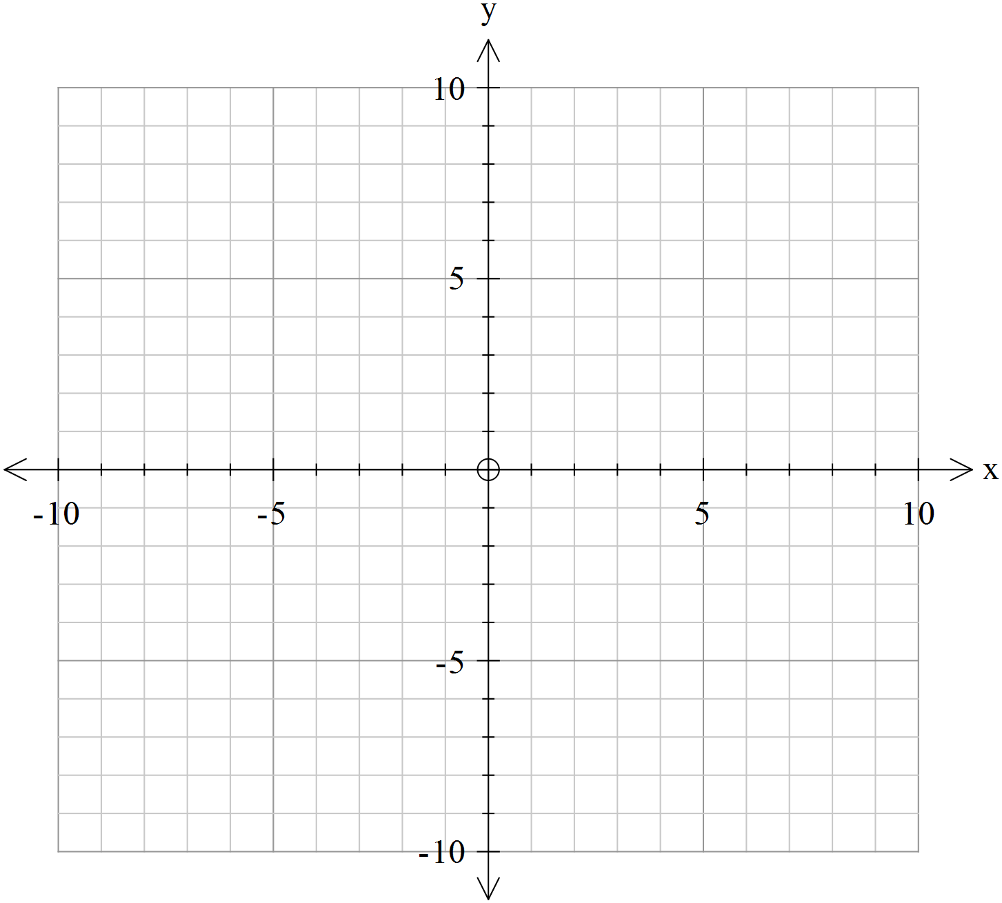

Question 4 (5 marks)

Find the Cartesian equation of the line perpendicular to the vector and passing through the point

